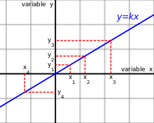
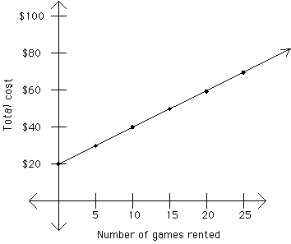
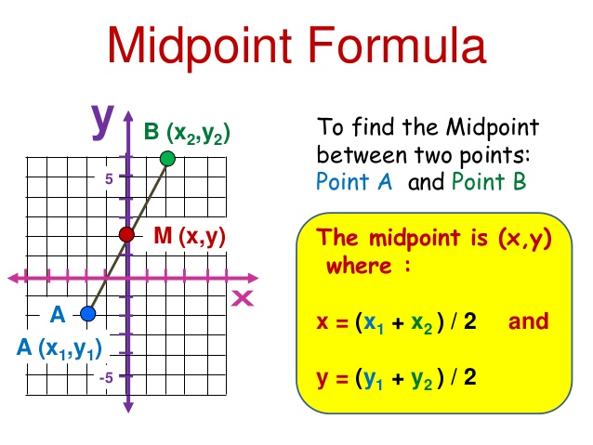
1.1.1 Mid-point
Direct Proportion
Eg.
x | 1 | 2 | 3 | 4 | 5 | 6
y | k | 2k | 3k | 4k | 5k | 6k
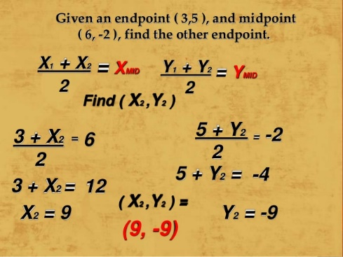
k
k
k
k
k
k
y= x
Difference:
Is a straight line gradient that passes through (0,0)
As the x-value is increased by 1 the y-values show a constant difference of k
- Both the x and y value increase or decreases in a constant amount
- Therefore, creating a straight line
1.2.3 Linearly Related Variables

Eg.
- Subt. The midpoint into the midpoint formula
- Separate the X and Y values
- Subt. The end point
- Work out
1.1.2 Finding end point
$$M=\frac{x_{1}+x_{2}}{2},\frac{y_{1}+y_{2}}{2}$$
Linear Equation: y=mx + c
When c is the y-intercept
**if line cuts y- axis

y = mx + c
1.1.4 Linear Equations

To Find the Distance of Two Points:
To find the gradient:
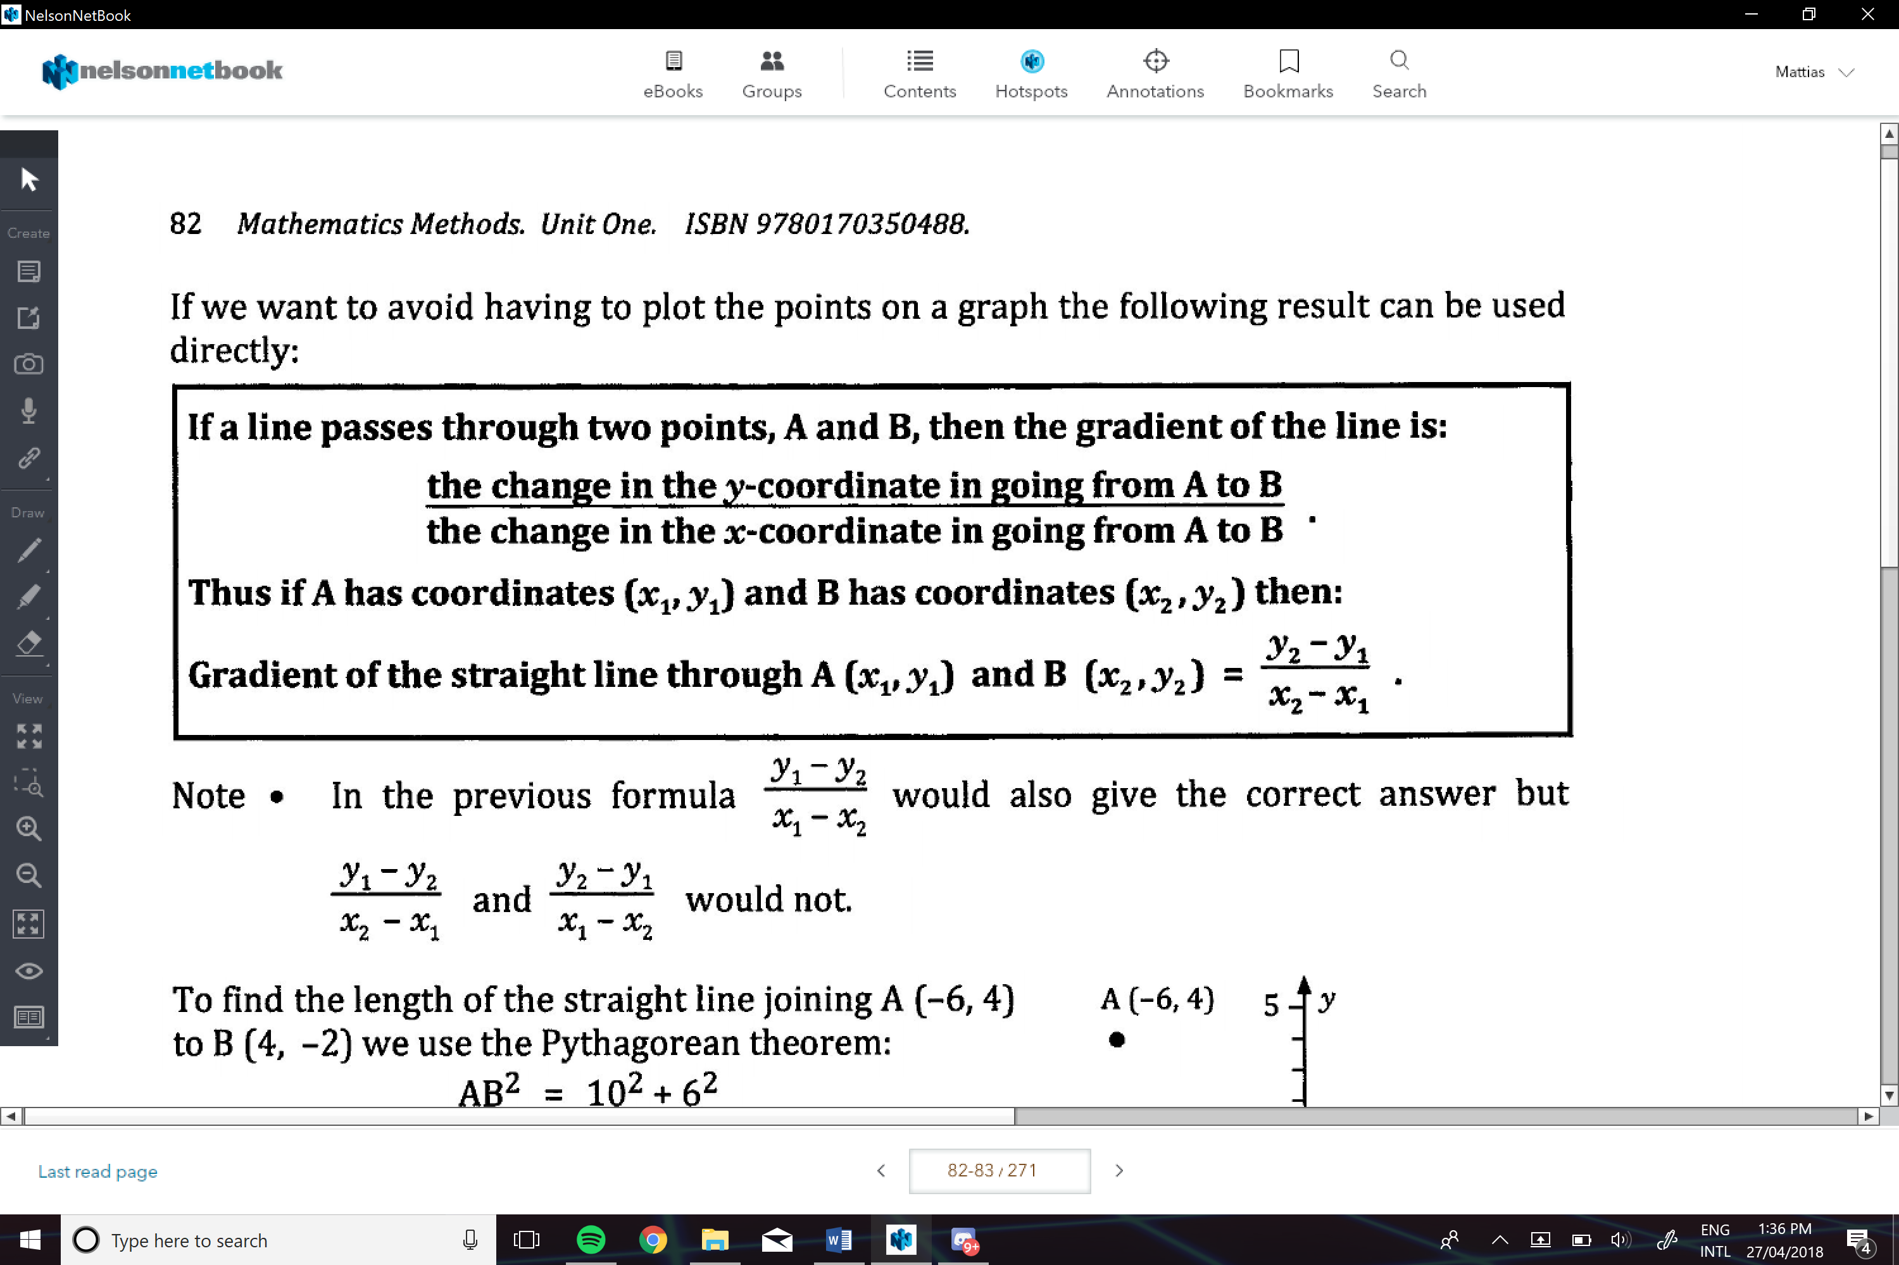
Where the line goes through the y axis
If increased by 5 units then it will transform the line 5 units vertically upwards
Y-intercept (c)
1
2
e.g. m=1/2
1
5
e.g. m=5
The more m increases the steeper the line is
If 0>m then the line is decreasing
If m>0 then the line is increasing
- Can determine if the line is increasing or decreasing
- Can determine the steepness
Gradient (m)
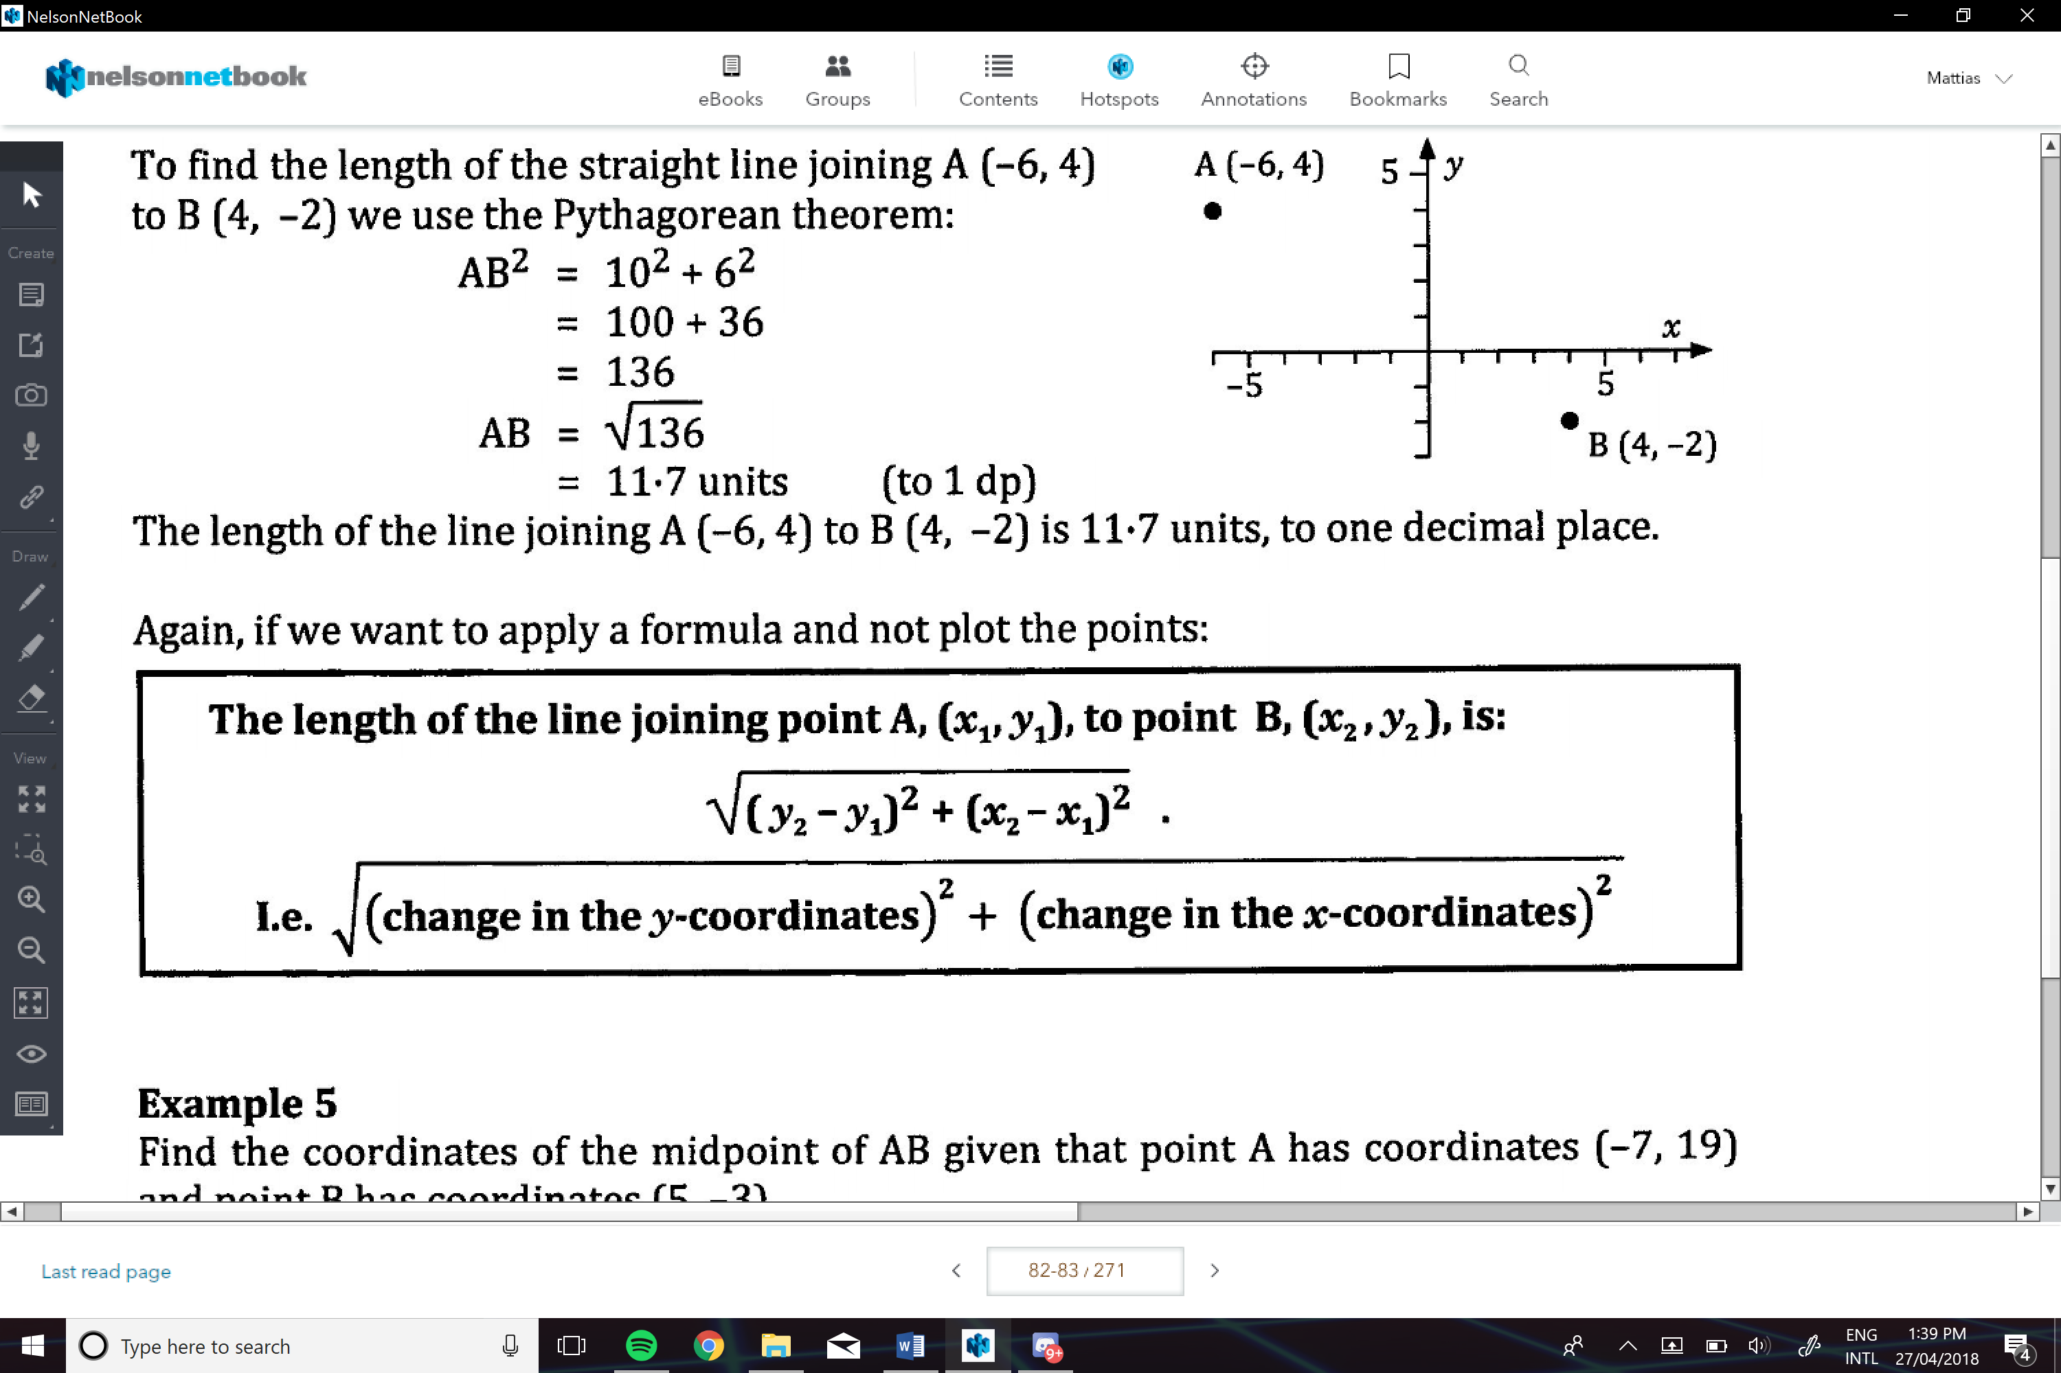
e.g.
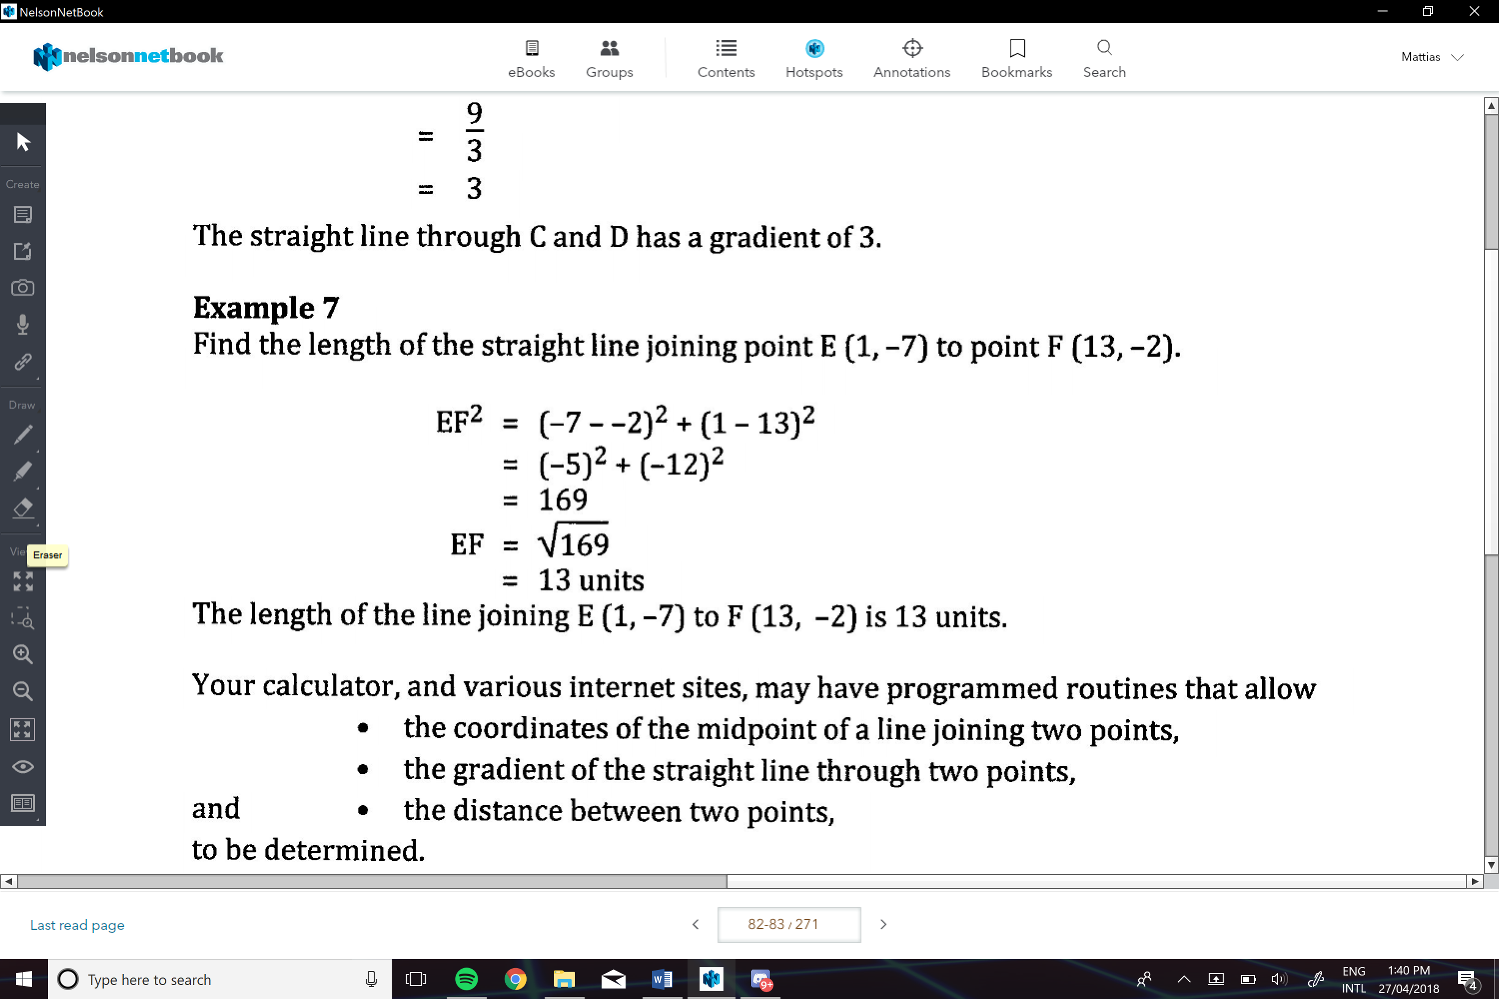
Determining the Equation of a Staight Line:
If given the gradient and on other point:
- Subt. the gradient into y=mx+c
- Subt. the given point
- Find c
- Then enter the gradient and y-intercept to find the equation
e.g.
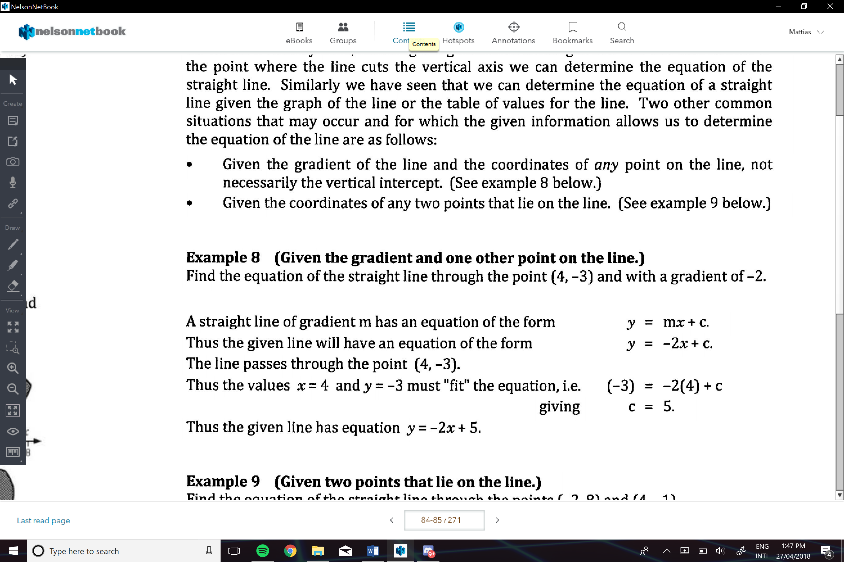
Given Two Points on the Line:
- Find the gradient of the line
- Subt. M into y=mx+c
- Subt. one of the point
- Finc c
- Then enter the gradient and y-intercept to find the equation

e.g.
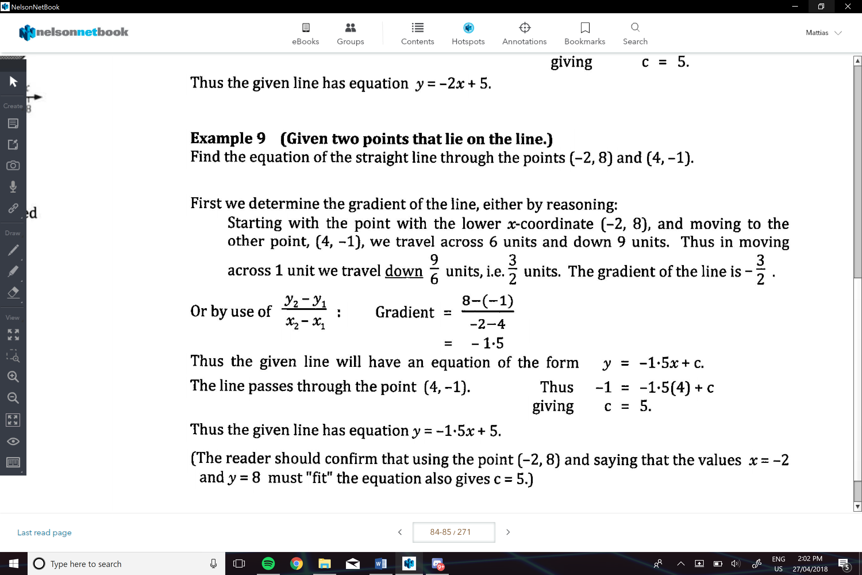

Given enough info that allows us to determine two points that lie on the line
- Then proceed like previous ways.
- Find one point
- Find the second point
- Find the gradient
- Find c
e.g.
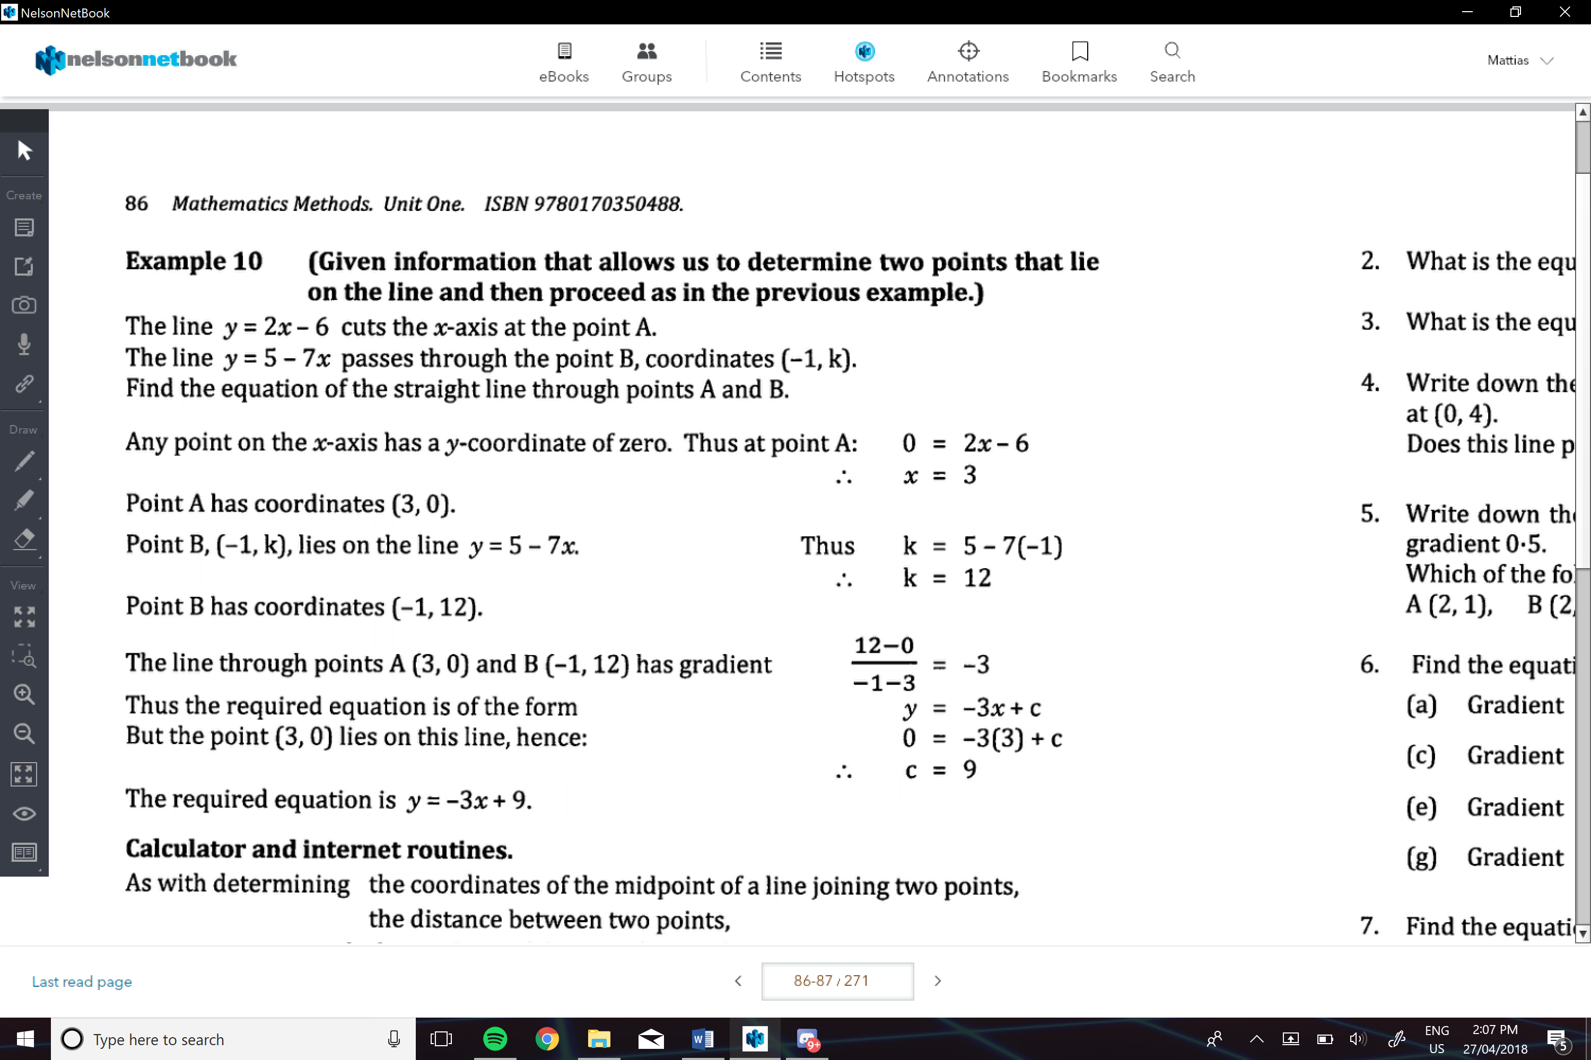

Parrallel Lines:
Are two lines that have the game gradient , and never touch
Perpendicular Lines:
Two lines that intersect each other at exactly 90º
- The gradients are the negative reciprocal of each other
-And the gradient should have a product of -1

